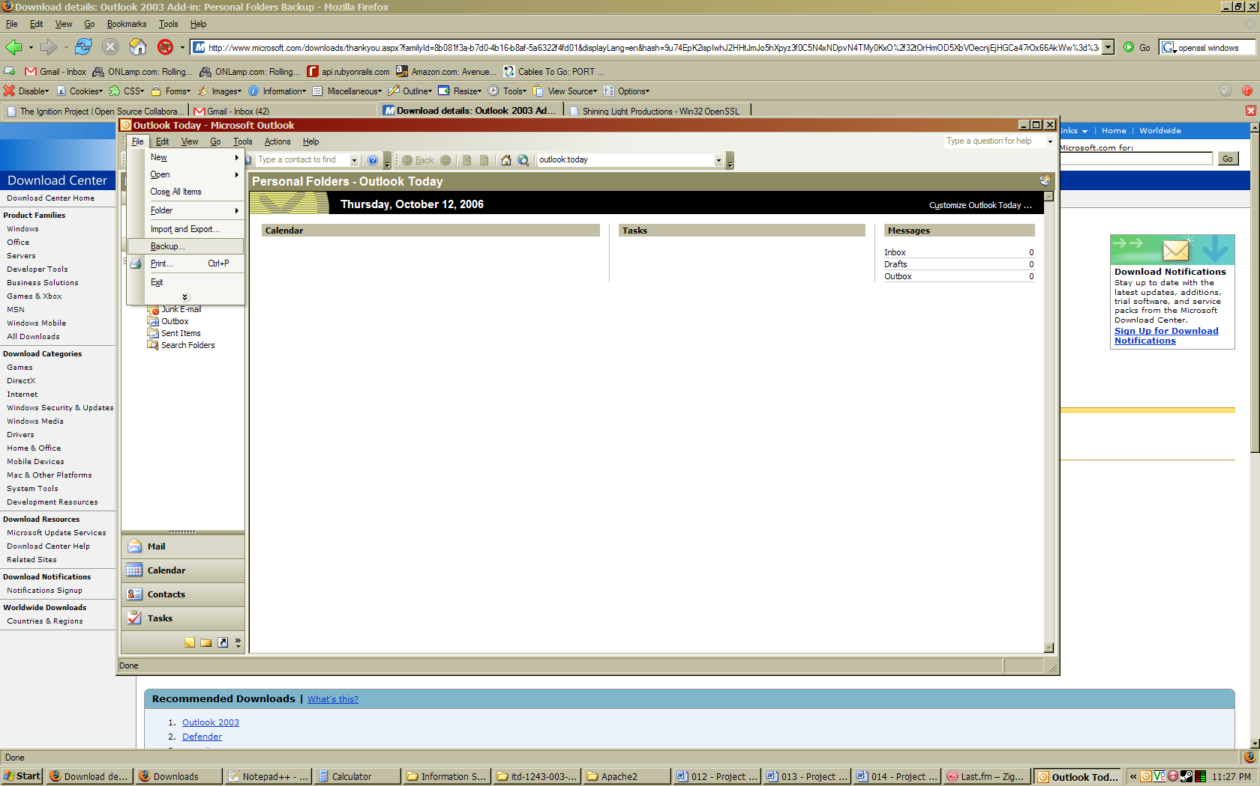
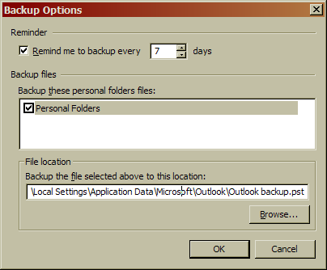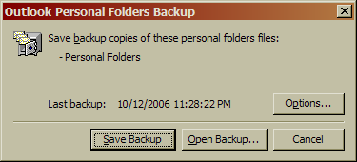

Summary
Backing up is important. I don’t think I can say much about that other than that statement. I don’t use Outlook. Instead, I depend on Google’s massive redundancy on Gmail. I figure that I’ve never seen Google go down, ever, so they probably care a lot about keeping my data safe. If you do use Outlook though, probably this is a good idea. It’ll help prevent problems like magnets, bullets, little brothers, little sisters, etc. Or, rather, it’ll make those problems less of a pain should they occur.

